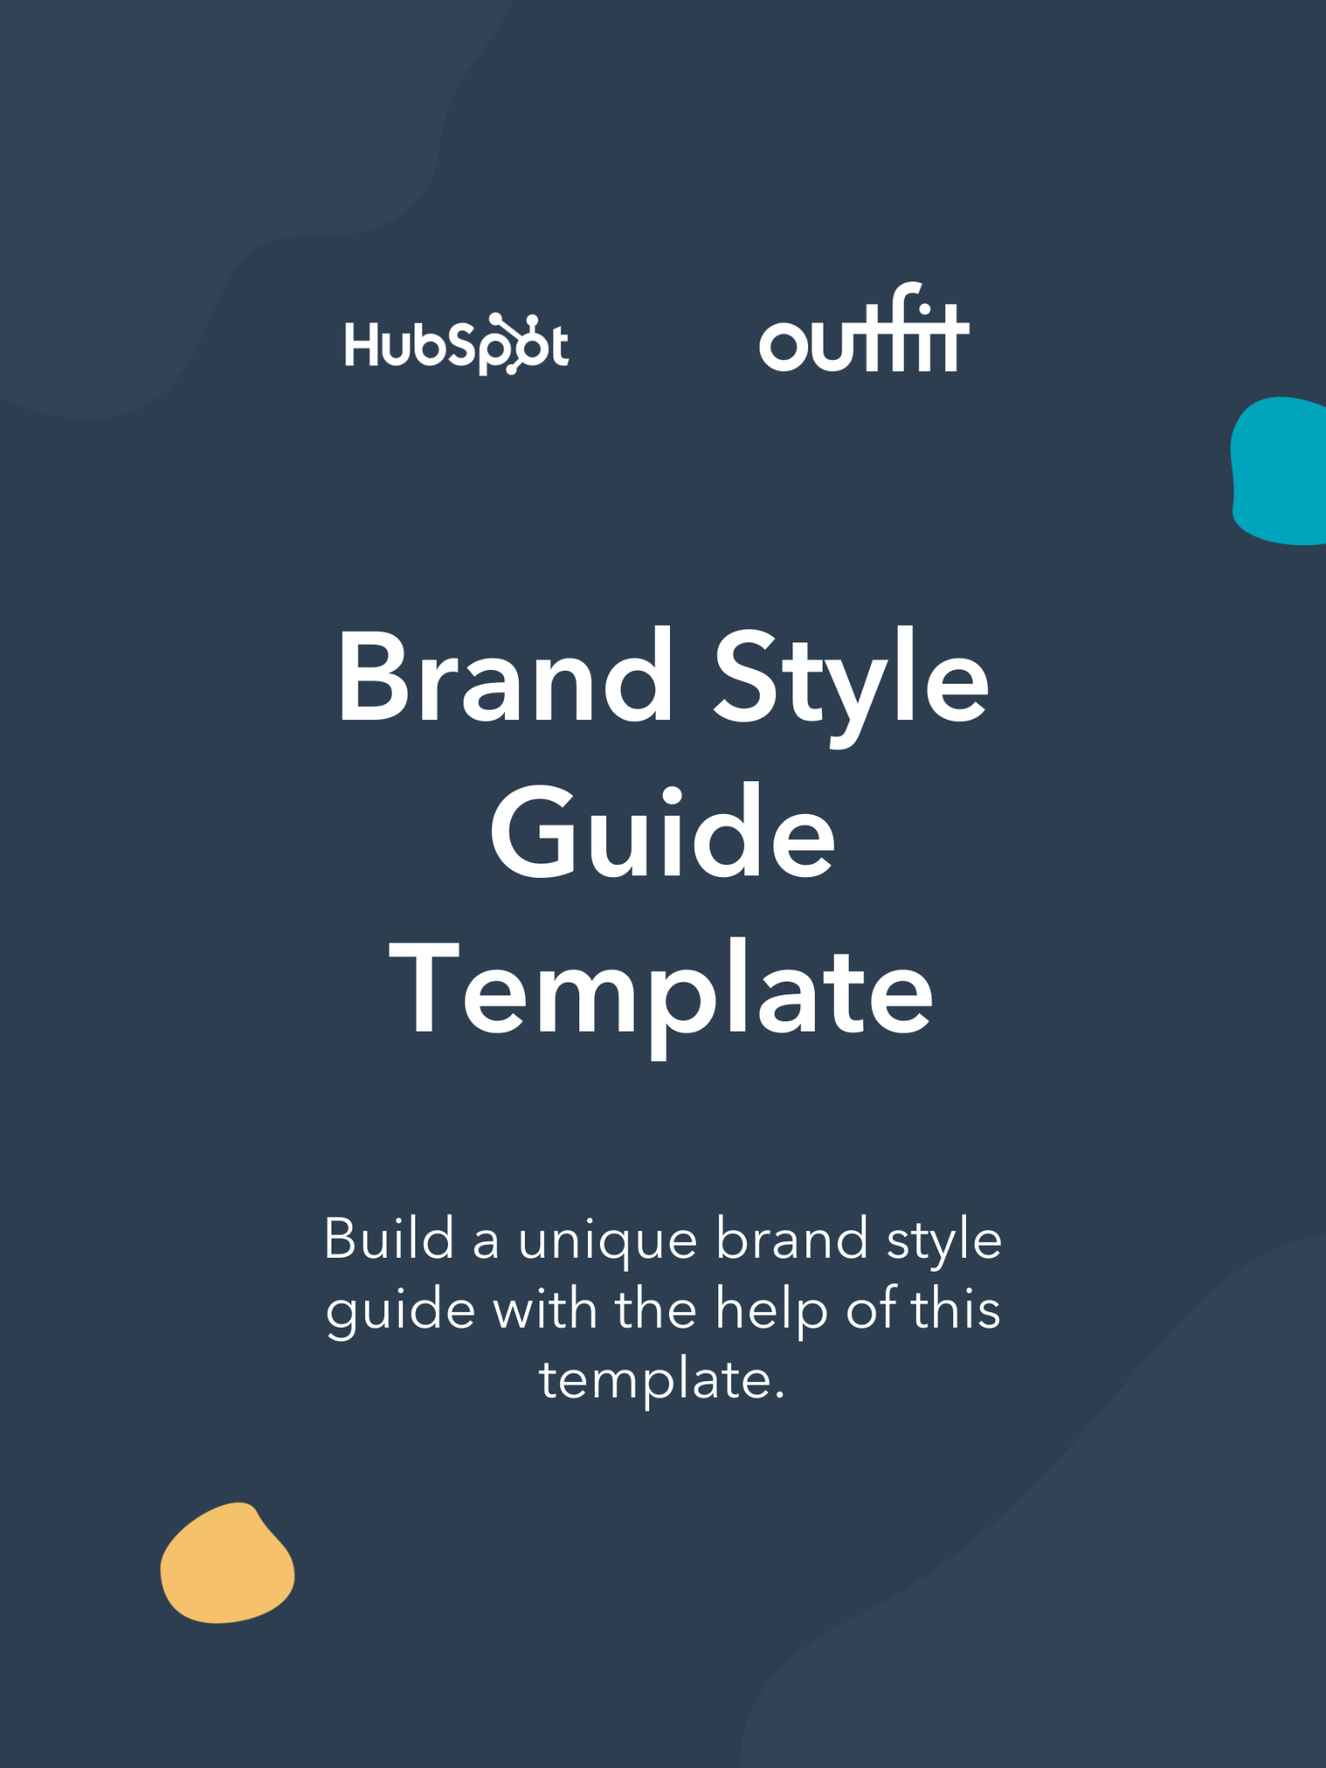

|  |
| --- |
| **Hi There.**  Thanks for Downloading This Resource.    You Can Edit Your Own Version in One of Two Ways:   1. Edit this version to fit your needs. 2. Go to “File” > “Download As” > “Microsoft Word” to Download. |
| ↓↓↓  How to Use This Template  This template was built for you to build out a brand style guide for your business. Simply erase the *italicized information* and **[bracketed instructions]** under each header and replace them with what makes sense for your business and your brand.  **Note that all sections and definitions in this template are mirrored in the ebook included in your download. For real visuals, examples, and elaboration on any of these concepts, please read the corresponding section in the included guide.**  Once complete, this plan can be shared with your designers, customer-facing roles, and content creators to ensure a consistent brand experience.  Keep in mind, this template is designed to be completely customized by your company. If you feel there are sections included that you would rather omit, or if you think a section is missing, you are encouraged to make those changes as you see for your business. |

|  |  |
| --- | --- |
| Make your brand stand out online with HubSpot.  Learn more about HubSpot’s Marketing Hub Software for scaling businesses. |  |
| [**Get Started With Marketing Hub**](https://www.hubspot.com/products/marketing?utm_source=offers&utm_medium=offers&utm_campaign=seondary-conversion_brand-style-guide-template_template) | |

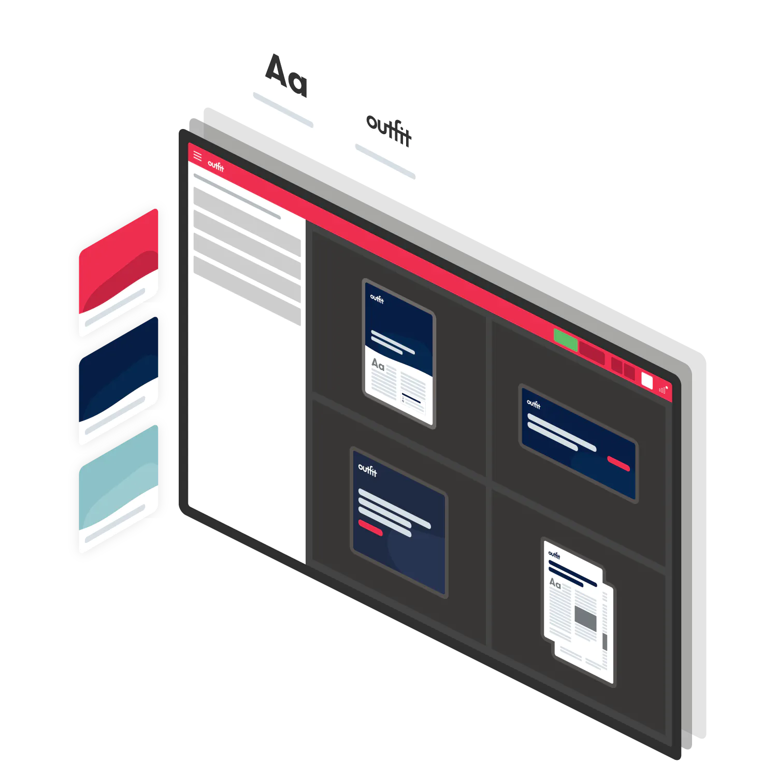

|  |  |
| --- | --- |
| Ensure brand consistency with Outfit.  Outfit provides all the templates, assets and tools your organization needs to create marketing collateral within your defined brand guidelines. |  |
| [**Request a Demo**](https://hubs.ly/H0L1H1H0) | |

(Keep scrolling to templates)

↓↓↓

**[Insert Company Logo]**

[Company Name]

**Brand Style Guide**

**Drafted By: [Insert Author Name and/or Team]**

**Last Updated: [Insert Date Last Updated]**

**Brand Overview**

*In this section, you’ll establish your brand with an overview of factors unique and core to your brand and your business. Telling the story of your brand, what it stands for, and how it has evolved is an important part of defining your brand and its values, as well as building trust with your community.*

*Your brand story (or narrative) will provide context for and give meaning to the visual elements you go on to develop to represent your brand, creating a cohesive brand image.*

**Brand Name**

*State your brand’s name and explain its origins. Why was that name chosen for the business? Did it change from something else? What do you hope people think of when they hear the name of your brand?*

**[Enter Brand Name & Origin]**

**Brand Purpose**

*Brand purpose is your brand’s reason for being – beyond making money. It should connect with customers on an emotional level and helps customers choose brands that align with their beliefs.*

**[Enter Brand Purpose]**

**Brand Promise**

*A brand promise is the value or experience your customers can expect to receive when they interact with your company. Elaborate on your brand’s promise in this section.*

**[Enter Brand Promise]**

**Brand Values**

*We all act according to our values, and companies should as well, so it’s important to take the time to define your brand values so they can easily be understood by your employees, customers, partners, and the market. In this section, explain what your brand values are, why they were chosen, and how they should be embodied throughout all branding.*

**[Enter Brand Values]**

**Brand Personality**

*An attractive, funny, or even provocative personality can be a huge asset for a brand. Describing the key character traits your brand embodies instantly makes it easier for designers, writers, and other creative contributors to ensure that the message they’re communicating on any channel remains on-brand and dials up the appropriate personality trait.*

**[Enter Brand Personality]**

**Brand Visual Foundation**

*Strong brands have clearly identifiable colors, logos, and typefaces that make their visual identity easily recognisable, as well as clear rules for how these should – and shouldn’t – be applied.*

*Before choosing or updating your core brand elements, have a look at what your competitors are doing to make sure your brand stands out and accurately reflects your desired brand image.*

**Business Logo**

*Logos are visual shortcuts for identifying a brand. They may be made up of symbols, shapes, and stylized text or a combination of all three, and through the visual choices made should evoke a company's brand story. For some brands, the logo is so well-known it can be used independently of the brand name.*

*In this section, include images of your logo, and if this is a living document, consider linking out to a brand assets folder so your team can access the correct logos.*

**Primary Logo**

*Provide your logo in a variety of sizes and file formats for download and show how it works in a variety of situations* – *the less you leave to chance, the better for your brand. You’ll need different formats for print and digital, and also for designers, developers, and external partners, as well as internal users.*

**[Enter Primary Logo Image and Assets Here]**

**Secondary Marks and Symbols**

*Your brand should look consistent in every situation, from the tiniest favicon to the biggest poster or billboard. Your secondary logo, mark, or symbol can be used in places where your normal brand won’t fit – such as the open tabs on your internet browser.*

*Secondary logos should evoke the main brand, repeating some of the shapes, colors or elements. In some cases, you may have a symbol that can be used on its own, or a separate logo to identify your corporate brand identity.*

**[Enter Secondary Imagery and Assets Here]**

**Size and Spacing**

*When you’ve worked so hard to create a logo that perfectly represents your organization or brand, it’s important it has space to breathe, or the impact of all that effort will be wasted.*

*That’s why your logo should include specifications for minimum size, and how much space to include around the logo symbol or wordmark: the ‘exclusion zone’.*

**[Enter Size and Spacing Protocols Here]**

**Colors**

*There are few things more crucial to rapid recognition of a brand than color* – *which is why it’s so important for people who use your brand to get your official colors and usage right.*

*This includes your official brand colors, your extended color palette, and the colors against which your brand can be used. Reproduce the color, along with the RGB, HEX, CMYK, and PMS codes, and be clear about your primary, secondary, accent, and background colors.*

**Primary Brand Colors**

*Color should be used judiciously to evoke the emotion or experience with which your brand wants to be associated. In this section, include an outline of which colors and shades are appropriate to use when representing your brand.*

**[Enter Primary Colors Overview Here]**

**Extended Color Palette**

*Most brands find they need more than two or three colors to create on-brand marketing materials for the range of channels and occasions in which their brand appears. An extended color palette featuring a range of approved colors provides additional flexibility while continuing to safeguard brand consistency. Consider linking out to a dedicated web page for your extended color palette if there’s too much information to fit on one page here.*

**[Insert Extended Color Palette Here]**

**Color Ratios**

*Whatever your brand colors, it pays to stipulate the ratio in which those colors should be used. Elaborate on best practices in this section.*

**[Insert Color Ratios Here]**

**Accessibility**

*What are your accessibility protocols? These may include nominating high color contrast ratios for text and interactive elements, considering mobile audiences, avoiding problematic color combinations such as red and green, and by not using color as the only differentiator when it comes to denoting text links.*

*It may also include using plain language, providing important information in text, rather than images, to make it accessible to screen readers, and captioning videos.*

**[Insert Accessibility Guidelines Here]**

**Typography**

*At its best, typography can distinguish your brand from the crowd, conveying your brand personality in an instant, attracting and holding your audience’s attention, building recognition, establishing a sense of occasion, structuring information, and promoting understanding.*

*The typefaces you choose to represent your brand should be easy to read and flexible enough to cover all the times and places you need to say something.*

**Primary Font**

*Consider choosing a range of primary fonts to suit different uses, platforms, and occasions. Nominate the different sizes and weights you’d like to see used to represent your brand.*

*While custom fonts can be very distinctive, don’t forget to consider how your font choice impacts your online presence. Some channels, web servers, and marketing automation tools will override your custom font with a web standard font such as Helvetica or Arial. It’s worth defining your digital fonts to ensure internet assets don’t go rogue*. *You may also want to link to where the font can be downloaded if it is a unique or custom font.*

**[Insert Primary Font Here]**

**Secondary Font(s)**

*Secondary fonts should provide you with all the flexibility you need to communicate your brand in different channels, reflecting the different tones your brand may need to strike. You may also want to link to where the font can be downloaded if it is a unique or custom font.*

**[Insert Secondary Font(s) Here]**

**Type Scales**

*Type scales show how your fonts work together to communicate in a harmonious way and can be applied broadly to create a uniformity across a range of brand materials – for example, by increasing or decreasing fonts at the same ratio.*

**[Insert Type Scales Font(s) Here]**

**Web Fonts**

*Some fonts work well in print but don’t look great on screen and vice-versa. If your brand exists mostly online, make sure you select fonts that are optimised for digital. Similarly, if you’re planning on translating your website into different languages, make sure your font comes in all the alphabets and with all the features you require. You may also want to link to where the font can be downloaded if it is a unique or custom font.*

*It’s also worth defining a fallback font to be used if your specified font is not available. The range of system fonts that come standard with most devices has improved, but you can also choose from a wide range of web fonts.*

**[Insert Web Font(s) Here]**

**Typography Principles**

*Give some guidance around how your typefaces should be presented: for example, leading and spacing, whether you centre or justify copy, and font color.*

**[Insert Typography Principle(s) Here]**

**Brand Architecture**

*If your organization includes a number of brands, it’s important to organize and present them in a logical way that makes sense to your customers and helps grow the value of your family of brands. This section will help you explain the protocols for doing that.*

**Brand Hierarchy**

*There are three main brand hierarchies:*

* ***Branded house:*** *Sub-brands share a name with the main one and are subordinate to it.*
* ***House of brands****: The parent brand is not reflected in the other brands and may remain in the background.*
* ***Hybrid:*** *Middle ground in which a parent brand is important to the sub-brands but may not share a name with them. The parent logo may be incorporated into some of the sub-brands.*

*Whether and how your sub-brands reflect or support the primary brand – and vice versa – will affect how they should be treated in your brand style guide: in some cases it may add value to share branding elements, and in others, not so much.*

**[Enter Brand Hierarchy Overview Here]**

**Logo Lockups & Co-Branding Options**

*Logo lockups are a precise arrangement of individual brand elements to create a new whole. They are often used to relate a sub-brand to a parent brand and may also be used to denote how other elements, such as taglines and external partner brands, should appear.*

**[Enter Logo Lockups & Co-Branding Options Here]**

**Grid**

*One of the easiest ways to achieve an organized, on-brand design is to apply a grid system. Grids provide a consistent experience across multiple features, documents and devices, and ensure brand elements and other content is arranged in an orderly fashion. If you use a team design software, you can also link out to image templates with grids in this section.*

**[Enter Grid Best Practices Here]**

Visual Language Elements

*Photography, illustrations, and other supporting visual elements complete the picture your brand presents, and when they’re all in harmony, they create a powerful overall impression.*

*This section is dedicated to an overview of which of these elements you use, when they should be used, and why.*

**Photography**

*Be specific about your photographic style by referencing factors such as:*

* *Whether you want to show people looking at the camera or not.*
* *How close-up your photography should be.*
* *How light should be treated.*
* *The mood you’re looking to capture or evoke.*
* *Composition.*
* *Color.*

*Consider supplying a library of approved images press and bloggers can access or use, as well as a centralized* [*digital asset library*](https://outfit.io/asset-library-digital-asset-management) *of approved imagery for internal stakeholders.*

**[Enter Photography Guidelines / Library Here]**

**Video**

*Video should be held to the same stylistic guidelines as video. Also, brands are increasingly including B-roll in brand style kits, so consider linking to your B-roll library if you have one.*

**[Enter Video Guidelines / Library Here]**

**Illustrations**

*Illustrations that use a consistent color palette and style are a great way to set your brand apart from the competition. They can be used to explain complex ideas, express your brand personality, and echo your brand values.* *If you use illustrations, explain the best practices for when and how to use them in this section. Also, if your business has an illustration library, include a link to it here.*

**[Enter Illustration Guidelines / Library Here]**

**Mood Boards**

*Mood boards can be a great visual shortcut to conveying a brand image in seconds without needing to wade through pages of instructions. They should bring together a selection of visual assets that explain exactly who your brand is.*

**[Enter Mood Board Guidelines / Overview Here]**

**Textures and Patterns**

*You may want to include official textures and patterns in your style guide. Here’s where you’ll do so.*

**Icons & Avatars**

*Icons and avatars have become increasingly important with the development of new digital channels, apps and platforms.*

**Iconography**

*Developing a library and style of iconography that can be used consistently across your business will boost your brand consistency and impact in all channels. Plus, it will allow your brand to denote complex concepts with an easily recognisable visual shortcut.*

**[Enter Iconography Guidelines / Library Here]**

**Avatars**

*The use of avatars is also on the rise, and – particularly for technical brands – they can be a great way to humanise your brand in a distinctive way.*

**[Enter Avatar Guidelines / Library Here]**

**Data Visualisation**

*Infographics, charts, tables and diagrams – if your brand features any of these elements, it’s important to standardise them to ensure the way you represent data is both consistent and in keeping with your brand.*

**[Enter Data Visualization Guidelines Here]**

**UI Elements**

*Any brand with a website should consider including UI elements in its brand guidelines. From buttons to navigation bars, there are many moving parts and documenting how they should look and behave will make it easy to communicate this to designers and developers.*

**[Enter User Interface Guidelines / Library Here]**

Brand Voice

*Last but not least, when you have defined your brand personality, use it to develop your brand voice. Not all brands sound the same – and that’s a good thing. Defining how to write for your brand will enable you to bring the same consistency that applies to your visual brand elements to the written word.*

*In defining your brand voice, consider your audience, your brand category, and the markets in which you operate, as well as your approach to headlines, sentence style, grammar and punctuation, common abbreviations, and unique terminology.*

**Voice**

*Your brand voice shouldn’t change. Regardless of the situation, it’s how someone will know they’re hearing from your company on a blog post, a product page, or a response on social media. It is signature to your brand and ensures consistent messaging.*

**[Enter Brand Voice Guidelines Here]**

**Tone**

*On the other hand, your tone may alter depending on the situation. Some brands think of it as dialling up or dialling down different characteristics at different times. For example, how should your social media manager respond to a tweet from a delighted customer versus an unsatisfied one?*

**[Enter Brand Tone Guidelines Here]**

**Resources and Tools**

*Once your brand style guide has been created, the real work begins. Communicating and distributing your brand style guide, and ensuring your stakeholders always have the information and tools they need to create on-brand materials, can be a challenge for brand teams.*

*Monitor how your brand guidelines are being implemented to ensure they’re applied correctly, and as your brand grows, remember to take advantage of the available technology to ease the load.*

*Many brands make their brand standards available online via static downloadable PDFs – but there are a variety of other tools you can use to ensure your brand stays on track*. *The most common ones are listed below.*

**Brand Websites**

*Dedicated brand websites exist for maximum accessibility of your brand assets.*

**[Enter Link to Brand Website(s) Here]**

**Interactive Websites**

*Interactive websites are great for showcasing dynamic brand elements like B roll and stock footage.*

**[Enter Link to Interactive Website(s) Here]**

**Centralized Asset Libraries**

*Make approved imagery, illustrations, and other on-brand materials readily available via digital asset managers.*

**[Enter Link to Centralized Asset Librar(y/ies) Here]**

**Brand Automation Systems**

*Enshrine brand guidelines in responsive templates covering all commonly used brand executions, enabling stakeholders to rapidly create on-brand materials.*

**[Enter Link to Brand Automation System(s) Here]**

**Additional Page Placeholder**

*Did we miss something?*

**[Enter More Information Here If Needed]**